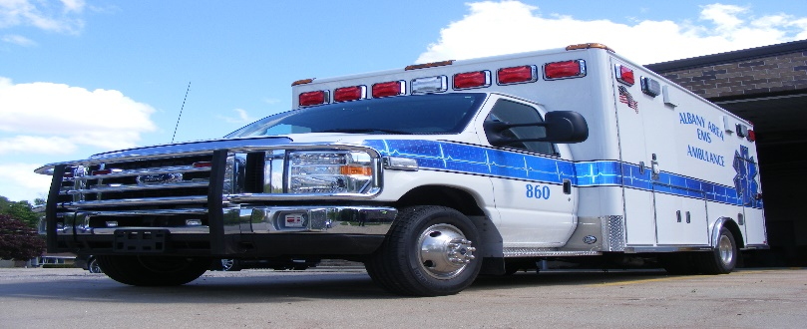
Albany Area EMS
Application for Membership

NAME __________________________________________________________________
ADRESS ____________________________ CITY ________________ ZIP___________
PHONE _____________________________ EMAIL_____________________________
DRIVER’S LICENSE NUMBER _____________________________________________

POSITION APPLYING FOR:
AEMT___ EMT___ EMR___ DRIVER___ OTHER___

Are you currently licensed as an EMT or RN? Yes____ No _____
If yes, please provide your license number: ___________________________________
If no, are you willing to attend class to gain licensure? Yes ___ No ___
Have you ever been convicted of a felony? Yes____ No ___

REFERENCES

NAME _________________________________ PHONE _____________________
NAME _________________________________ PHONE _____________________
NAME _________________________________ PHONE _____________________

(Continued)
Please read carefully and sign:
By signing this application to become a member of AAEMS, I understand and agree to the following conditions of crew membership which is not limited to:
- I will submit to and provide all information necessary to enable AAEMS to complete a criminal background check prior to my employment and at such intervals as required by state law during my tenure with AAEMS.
- I acknowledge that AAEMS may contact the references I have provided as references in this application for the purpose of soliciting information and verifying statements made on this application.
- I will make myself available for one crew training per month and all mandatory training activities as required for licensure, re-licensure or as required by medical direction.
- I understand that my certifications, such as CPR, will need to be kept current along with my state license as an EMT. If they expire I will not be able to provide any type of patient care.
- I understand that there are minimum requirements of on call time and will fulfill those requirements each month or reimburse AAEMS for costs of licensure as agreed upon with the Educational Agreement.
- I agree to abide by the Bylaws and Policies and Procedures Manual as well as protocols set by medical direction. Failure to do so can result in disciplinary action which may include immediate dismissal from AAEMS membership.
- I understand that this application does not guarantee membership to AAEMS.
I have read and understand the above conditions of employment and/or membership with AAEMS. I agree to abide by the conditions set forth in this application and in the Policy and Procedure Manual of AAEMS. I hereby affirm and declare that the information provided by me on this application is true and correct to the best of my knowledge.

SIGNED: WITNESSED BY:

______________________________________ __________________________________
(signature) (signature)

______________________________________ __________________________________
(Print name) (Print Name)

__________________________________________________ _____________________________________________
(Date Signed) (Date Signed)

